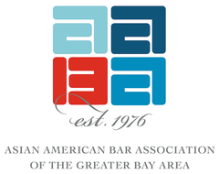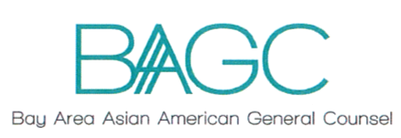

AABA IHCC & BA Asian American GC Network

GC Fellowship Program

Overview
Purpose: One of the goals of the Asian American Bar Association of the Greater Bay Area (AABA) and the Bay Area Asian American General Counsel network is to create engagement with the next generation of API senior in-house counsel and general counsels.

What: A one-year program (with quarterly sessions) directed towards high-potential senior in-house attorneys who are on the path to the General Counsel spot. The program will be comprised of a small cohort of senior in-house attorneys (maximum 10), who commit to the one-year program, and attend all four quarterly sessions. Each quarterly session is to be led by at least two different seasoned (or recently retired) General Counsel, who will each lead a fireside chat/discussion on personal and career development – e.g. soft skills, strategic thinking, aligning with the business, etc. Each program will be hosted by a different law firm sponsor, but the sponsoring law firm may not have any attorneys attend the program – only the post-program reception/dinner.

Quarterly sessions will be scheduled for dates in November, January, April, and June. Timing to be determined but will typically be a late afternoon session, followed by a reception or dinner.

Eligibility
- Minimum of 8 years of practice
- Minimum of 3 years of in-house practice
- Currently practicing in-house at a for-profit corporation or non-profit organization in the San Francisco Bay Area
Application
- Application questionnaire
- Personal Statement (as outlined below)
- Copy of your resume
Dates and other information
- The deadline to submit applications is Thursday, September 21, 2017.
- Fellows will be notified no later than Friday, September 29, 2017.
- The first fellowship program will be scheduled for November.
For questions and to submit this application, please contact us at info@aaba-bay.com.

AABA IHCC & BA Asian American GC Network

GC Fellowship Program

Name:

Current Title:

Current Employer:

Tenure at current employer:

Law school:

Year of law school graduation:

Address:

Personal Statement (approx. 500 words):

The GC Fellowship Program is designed to identify and support the next generation of API general counsels. Using specific examples from your professional life, tell us why you want to be a General Counsel and what makes you well-positioned for that role in the future.

Submit application, personal statement, and resume by September 21, 2017 to info@aaba-bay.com.

